Task No & Title: Unit 1 | Unit Descriptor This unit defines the competency required to operate a personal computer, including starting the PC, logging in, using and understanding desktop icons and their links to underlying programs, navigating a directory structure, saving work, printing, system checks and closing down the PC. This unit is a prerequisite to starting the course and should be completed as soon as possible.
Title: | 01_03 Peripherals Quiz
Suitable for Classes: | Certificate II in Information Technology
Area: | Technology & Enterprise
Teacher: | Mr Peter Faulks
Timeline | 1 Lesson  1
Date Due: | Today 1 hour credit

Task Brief:

Files Required

Items highlighted in yellow are tasks for you to complete
Items in Blue are help tips

Certificate II in Information Technology

Unit | Number | Title | Type | Hours
01 | ICAU1128B | Operate personal computer | Pre | 20
02 | BSBCMN106A | Follow workplace safety procedures | Core | 10
03 | ICAD2012B | Design organisational documents using computing packages | Core | 40
04 | CAU2005B | Operate computer hardware | Core | 20
05 | ICAU2006B | Operate computing packages | Core | 60
06 | ICAU2013A | Intergrate Commercial computing packages | Core | 25
07 | ICAU2231B | Use computer operating system | Core | 20
08 | ICAW2001B | Work effectively in an IT environment | Core | 25
09 | ICAW2002B | Communicate in the workplace | Elective | 20
10 | ICAS2014B | Connect Hardware Peripherals | Elective | 25
11 | ICAU2007B | Maintenance of equipment and consumables | Elective | 15
12 | ICPMM263B | Access and use the internet | Elective | 20
13 | ICAW2011B | Work individually or as a team member | Elective | 20
14 | ICPMM321B | Capture a digital image | Elective | 30
 |  |  | TOTAL


Operate personal computer Peripherals Quiz
Some places to look for answers.(Note links may no longer be active)

Glossaries and definitions relating to all Information Technology topics. www.whatis.com

Terminology, definitions and links to other sites. www.pcwebopaedia.com

Software drivers focusing on peripheral devices peripherals.about.com/cs/findingdrivers/

Microsoft Windows-related software drivers www.windrivers.com/
Device driverswww.drdriver.com/

Label the parts
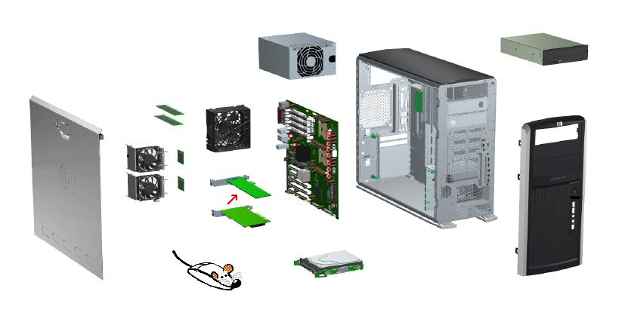
Side Cover

DVD CD Player

Complete the following activities:
1. Tick whether each device below is and INPUT or OUTPUT device and whether it is ESSENTIAL or OPTIONAL. (here is your tick ✓) alternatively you can fill the cell with colour
Peripheral | Input | Output | Essential | Optional
Printer
Monitor
Mouse
Keyboard
CD Burner
Scanner
Graphics Tablet
Touch Screen
Bar Code Reader
Microphone
2. Look at your computer at home. Make a list of all the INPUT and OUTPUT devices that are connected to it.
3. For each of the following devices, list one specification or criteria you would consider when deciding to buy it.
  - Monitor
  - Laser Printer
  - Modem
  - Scanner

Client requirements – hardware and software

Client wants to… | Hardware peripherals required & example | Software required & example | Consumables required | Could you show them how to connect and use it?
Digital copy of a magazine picture

Download image from a website

Connect to an integrated network

Become a participant in a business video-conference

Take a good quality photo of their son to go in his CV

Listen to music without disturbing others

Save 365 kb data to portable memory

Save 100 Mb data to portable memory

Save 500 Mb data to portable memory

Save 1.2 Gb data to portable memory

Save 50 Gb data to portable memory

Show a PPT presentation to a room full of people

Play a music file to an assembly of students

Record a voiceover for a PPT presentation

Print (draft) colour copies of a brochure for a client

ASSESSOR FEEDBACK FORM
Student Name:
Assessment Date/Due |  | Assessor’s Name: | Peter J Faulks
Training Package: | ICA05
Qualification: | ICA20105 Certificate II in Information Technology

FEEDBACK FOR FUTURE ACTION
Overall performance, gaps and feedback:

Assessment Record | Satisfactorily Completed
Task 1: Practical Activities | Yes | No
Task 2: Written Questions | Yes | No
Task 3: Observation | Yes | No

Is a reassessment required? Circle  Date of Reassessment if applicable: _____________________ | Satisfactorily Completed
   | Yes | No
Task 1: Practical Activities | Yes | No
Task 2: Written Questions | Yes | No
Task 3: Observation | Yes | No

Assessment of Competency completed: _____/_____/_____

Outcome: (Tick)
Competent |  | Not yet competent

Candidate Signature: | Date:
Assessor Signature: | Date:

Checklist of electronic, work and portfolio filing systems
01 ICAU1128B Operate personal computer
Name: | Competent | Yes | Not Yet

Section 1 Practical

Task Requirements
The task requires that you set up your electronic filing space, work folder and evidence portfolio in accordance with the following guidelines
Due Date
This task is to be submitted on 5 February 2011.
It is your responsibility to ensure that this task is submitted on time. If you are unable to submit this task on the specified date, it is your responsibility to see me to negotiate any extensions or any extra assistance that may be require.
Task Feedback
Your electronic filing system must contain the following (this must be evidenced through a print screen print out):

You must create a folder in your work space titled C2BSB.
Within that folder you are to create the following sub folders:

01 Operate personal computer
02 Follow workplace safety procedures
03 Design organisational documents using computing packages
04 Operate computer hardware
05 Operate computing packages
06 Integrate commercial computing packages
07 Use computer operating system
08 Work effectively in an IT environment
09 Communicate in the workplace
10 Connect hardware peripherals
11 Maintain equipment and consumables
12 Access and use the internet
13 Work individually or as a team member to achieve
organisational goals
14 Capture a digital image

- Your evidence portfolio (provided to you) must contain the following:
- Spine Label
- 5 file dividers with the following labels:
- Course Documents
- Term 1
- Term 2
- Term 3
- Student Assessment Record
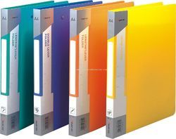
- Your work folder (provided by you) must contain the following:
- A two ring binder.
- A cover page with your name.
- 18 File dividers with the following sections:

- Time Plans
- Term evidence records
- 01 Operate personal computer
- 02 Follow workplace safety procedures
- 03 Design organisational documents using computing packages
- 04 Operate computer hardware
- 05 Operate computing packages
- 06 Integrate commercial computing packages
- 07 Use computer operating system
- 08 Work effectively in an IT environment
- 09 Communicate in the workplace
- 10 Connect hardware peripherals
- 11 Maintain equipment and consumables
- 12 Access and use the internet
- 13 Work individually or as a team member to achieve organisational goals
- 14 Capture a digital image
- Reflection
- Homework

Insert screen shot here:
Teacher Comment & Signature

Student Comment and Signature

Parent Comment and Signature

